**HTTP to HTTPS Redirection on Ingresses**

**Step1: -**   
Firstly, check whether the Ingress HTTPS load balancer IP is Static or Ephemeral. If it is not a static IP, make the IP static and provide a name for that IP.

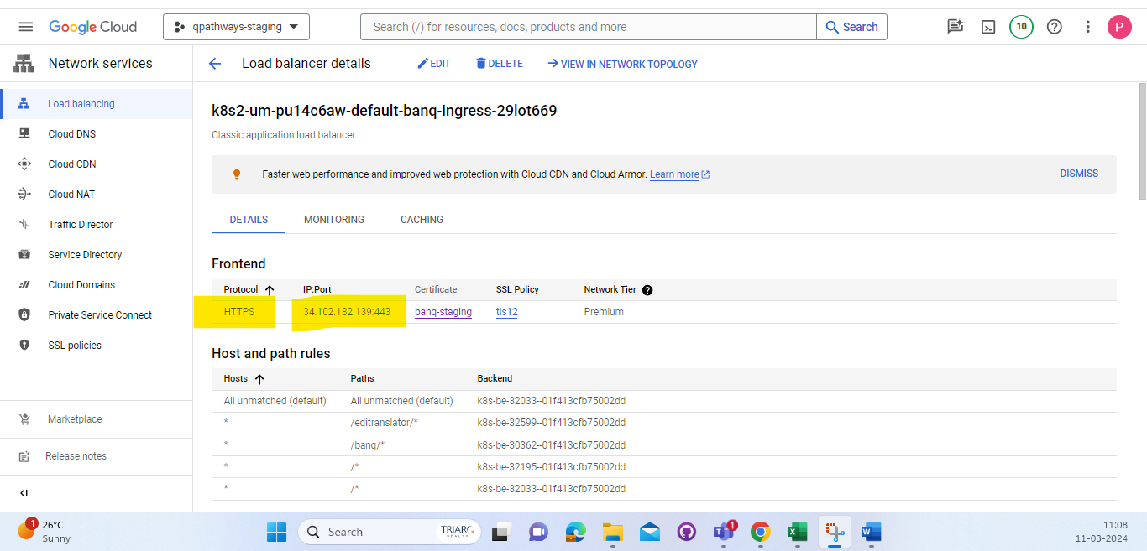

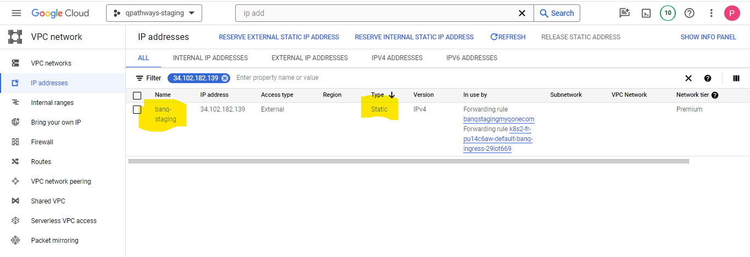

If it is not a static IP address, promote it to a static IP.  
Click on the three dots on the extreme right, and the option to "Promote to Static IP Address" will appear.

**Step1: -**

Deploy the frontend configuration file to each cluster within the project.  
We must use the following YAML file for deployment on the cluster.

apiVersion: networking.gke.io/v1beta1

kind: FrontendConfig

metadata:

name: frontend-config

spec:

redirectToHttps:

enabled: true

responseCodeName: PERMANENT_REDIRECT

We have to upload these YAML files with the name "frontend.yaml" and then deploy using the below command.  
\***kubectl apply -f frontend.yaml**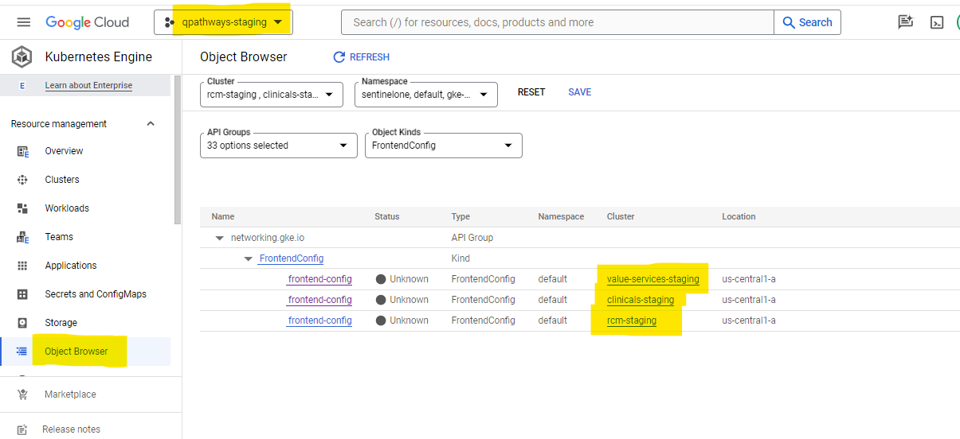

**Step3: -**  
After deploying the frontend.yaml file on the cluster level, we need to add annotations for HTTP to HTTPS redirection. Below are the three annotations.

**kubernetes.io/ingress.class: gce**

**kubernetes.io/ingress.global-static-ip-name: banq-staging**

**networking.gke.io/v1beta1.FrontendConfig: frontend-config**

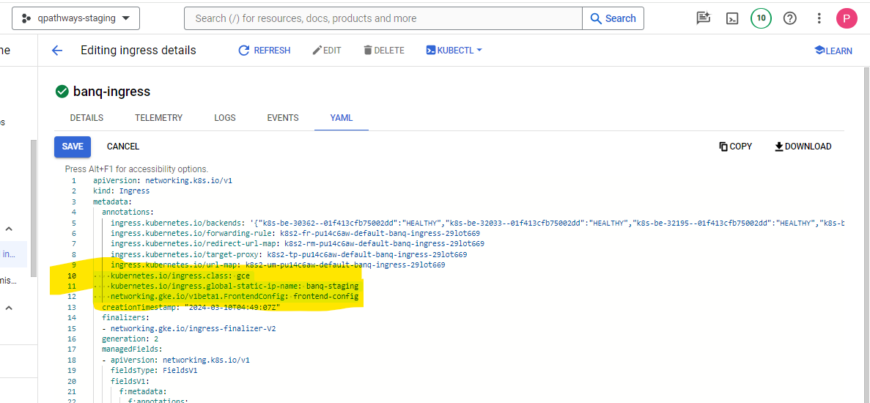  
If the redirection is successfully completed, we need to verify that the HTTPS load balancer IP and ingress IP match and check the URL redirection  
  
**Step4: -**  
If the ingress is using an old naming schema, it is not supported for HTTP to HTTPS redirection.

If the ingress is using an old naming schema, you may encounter errors like the one below:  
  
**Error syncing to GCP: error running load balancer syncing routine: loadbalancer default-qbanq-dev-ingress--328cacd62d105584 does not exist: ensureRedirectUrlMap() = error: cannot enable HTTPS Redirects with the V1 Ingress naming scheme. Please recreate your ingress to use the newest naming scheme.**

In this case, we need to take a backup of the ingress, the HTTPS load balancer's static IP, the certificate associated with that load balancer, the domain URL, and the Ingress yaml with all the backend services hosted on that ingress.  
  
Then we need to delete the old naming schema ingress and the HTTPS load balancer associated with that ingress as well.  
  
Create a new ingress with the latest naming schema, add all the backend services that were hosted previously, and include the frontend HTTPS load balancer with the existing static IP and certificate. Additionally, set up the redirection from HTTP to HTTPS.  
  
**Step5: -**  
If some ingresses are partially redirected with both HTTP and HTTPS load balancers using the same static IP, in such cases, we may encounter the following error. Additionally, if we forget to delete the existing load balancer with the same static IP before creating a new one, we will encounter the below error.

**Error syncing to GCP: error running load balancer syncing routine: loadbalancer default-qinsight-ingress--a7be6be6a6b7e402 does not exist: ensureRedirectUrlMap() = error: cannot enable HTTPS Redirects with the V1 Ingress naming scheme. Please recreate your ingress to use the newest naming scheme.**In this case, we need to delete the HTTP and HTTPS load balancers with the same static IP, as well as the existing load balancer with the static IP, before creating the new ones.